Financed by the Justice Programme of the European Union

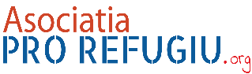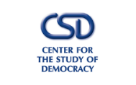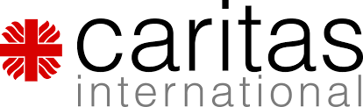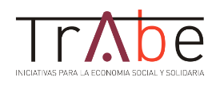
PROJECT
STRENGTHENING MULTIDISCIPLINARY COOPERATION TO ENSURE AN EFFECTIVE REFERRAL, ASSISTANCE, RIGHTS PROTECTION FOR VICTIMS OF HUMAN TRAFFICKING
JUST/2015/JACC/AG/VICT/9221
FINAL CONFERENCE
29-30 November 2018, Brussels

LEGAL ASSISTANCE AND REFERRAL CROSS BORDER CASES OF HUMAN TRAFFICKING
Speaker Silvia Berbec Lawyer Bucharest Bar
CASE STUDY

As result of cross border cooperation the Romanian prosecutors alongside their colleagues from Belgium, Spain, Italy, Germany were able to dismantle a network composed of 30 traffickers who for a period of 3 years were involved in human trafficking as well as money laundering. The network was composed of Romanian, Spanish, Italian, German citizens. Members of the network recruited Romanian young women from poor families (promising well-paid jobs abroad in restaurants, housekeeping, cleaning etc.) who once arrived in the destination countries were subjected to sexual exploitation in different clubs / streets. As result of the illegal acts around 3 million Euro were obtained by the offenders, most of the money being invested in cars, apartments, and other assets purchased directly on their behalf or on behalf of other family members. Authorities have seized 2 apartments, 4 luxury cars, 2 land plots. After the search (perquisition), weapons, laptops, mobile phones, cash money were retained by authorities.
Maria was one of the Romanian victims exploited in Spain for almost 6 months. After escaping from her traffickers, she arrived in a shelter administrated by a Spanish NGO. Maria accepted to cooperate with the legal authorities in this case. Maria had to give a written statement presenting what happen to her (how she was recruited in Romania, transported until Spain where was eventually subjected to sexual exploitation). She agreed also to request financial compensation for the damages suffered (has been beaten frequently, subjected to pressure / threatened by traffickers that they will harm the child she left with her parents in Romania). Maria did not spoke well Spanish, she needed a translator RO-ES for the entire procedure. Shortly after she provided the statement, she decided to go back to Romania as she found out her child was sick. The legal procedures in Spain had to continue. As the relation with her parents was not a very good one, Maria decided to stay with her child in a shelter administrated by a Romania NGO (before leaving from Spain, the Spanish NGO was in contact with the Romanian NGO about Maria case and the support she needed). Shortly after arriving in Romania, Maria found out that she will have to give an additional statement, because certain aspects were necessary to be clarified in the file.
Maria needs legal assistance / representation in Spain and in Romania. She is injured party, she requested compensation. Both NGOs have lawyers with who they cooperate in such cases.
- In a cross-border case, what are the necessary steps & procedures to provide legal assistance/representation in the destination and origin countries?
- How the legal needs assessment should be performed / how long-term legal assistance & representation should be provided by the lawyers?
- How the cooperation/communication between lawyers should take place?
- How the lawyers should cooperate in preparing the victim for this additional statement?
- How the lawyer(s) should communicate/cooperate with the other members of the multi-disciplinary team?

