Financed by the Justice Programme of the European Union
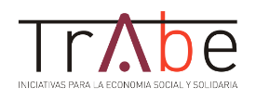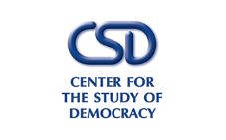
STRENGTHENING MULTIDISCIPLINARY COOPERATION TO ENSURE AN EFFECTIVE REFERRAL, ASSISTANCE, RIGHTS PROTECTION FOR VICTIMS OF HUMAN TRAFFICKING
JUST/2015/JACC/AG/VICT/9221

TRAINING FEEDBACK QUESTIONNAIRE
Date:
Location:
Organizer:
1. How do you assess the topics debated during the training?
a) Very Interesting b) Interesting c) Less Interesting d) Not Interesting

2. Did the trainers had an interractive manner of delivering the information in relation to the topics

a) Very interractive b) Interractive c) Less Interractive d) Not Interractive

3. Do you consider it was sufficient time allocated for discussing each topic?
a) Plenty b) Sufficient c) Limited d) Not Enough

4. Based on your work activity, please indicate what was from your point of view the most relevant information that you could use when assisting / protecting the rights of the victims of human trafficking

5. Other comments (if any)

