Financed by the Justice Programme of the European Union
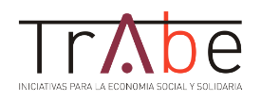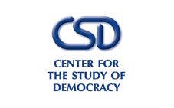
PROJECT
STRENGTHENING MULTIDISCIPLINARY COOPERATION TO ENSURE AN EFFECTIVE REFERRAL, ASSISTANCE, RIGHTS PROTECTION FOR VICTIMS OF HUMAN TRAFFICKING
JUST/2015/JACC/AG/VICT/9221
WORKSHOP & STUDY VISIT
EVALUATION QUESTIONNAIRE
Participant Name....................
1. How do you assess the topics debated?
a) Very Interesting
b) Interesting
c) Less Interesting
d) Not Interesting
2. Did the speakers / trainers had an interractive manner of delivering the information in relation to the topics
a) Very interractive
b) Interractive
c) Less Interractive
d) Not Interractive
3. Do you consider it was sufficient time allocated for debating each topic?
a) Plenty
b) Sufficient
c) Limited
d) Not Enough
4. Do you consider the information obtained as result of the event will be usefull in your further activities? Please explain your answer.

